# Training Outline: Policies and Procedures

## Introduction

1. As you know, CA associates are transforming over to the Model Platform. This change was decided for several business reasons that include consistency in customer care, etc. As a result of your conversion to the Model platform, several procedures will change to the model standards. Associates need to understand the new procedures in order to continue providing the same outstanding service to our customers.
2. You will learn about the many changes and updates as they pertain to your specific job role.

## Content

1. PRO
   1. The changes you will learn about come directly from PRO. The first thing you will do is to change your current version/view of PRO from CA to Model. To do this follow these steps (you can look at the image for guidance as well):
      1. Access PRO
      2. Hover your mouse over the “Select other version” as indicated in the graphic
      3. Click on Banking Center Model as indicated in the graphic

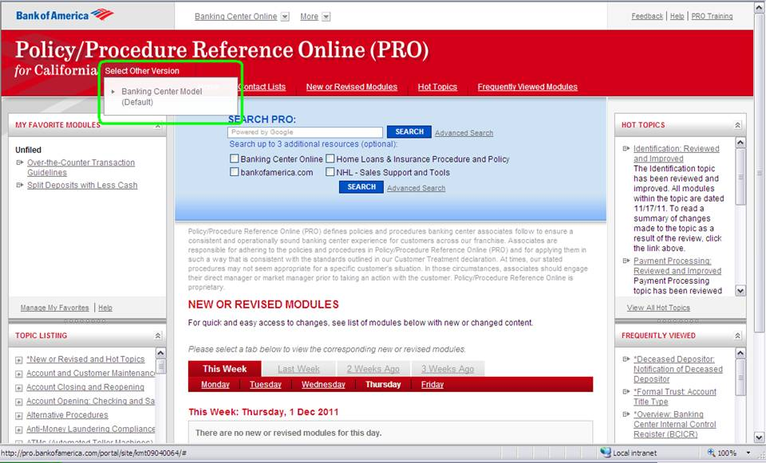

1. CA State Entity
   1. Learning Objective: Upon completion of this topic you will understand that CA is a one state entity upon completion of the Transformation to Model.
   2. Currently, CA is broken up into two state entities:
      1. Northern CA - 138
      2. Southern CA - 139
      3. After the transformation to the Model, CA will be a one state entity - 138
2. ICA
   1. Learning Objective: Upon completion of this topic, you will understand the process impacts due to the changes to the ICS ticket routing numbers.

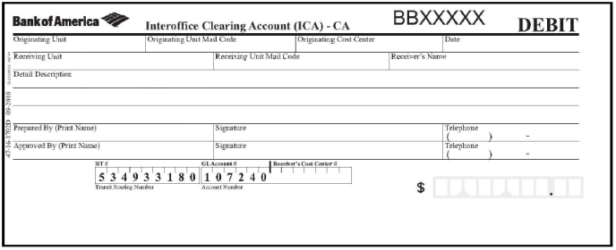

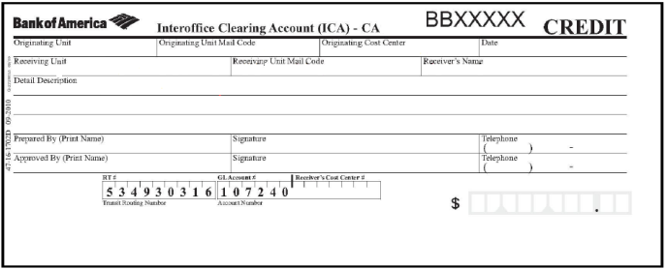

* 1. There are routing transit changes for ICA tickets.
  2. Tickets will have different RT numbers on the original and copy
     1. The top portion is a debit ticket
     2. The bottom portion is a credit ticket
  3. Understand the process impacts due to the changes to the ICA ticket routing numbers.
     1. There are Routing Transit changes for some ICA tickets. Need to identify which tickets.

1. CD/IRA Withdrawals or Deposits
   1. Learning Objective: Upon completion of this topic, you will process CD/IRA withdrawals and deposits using the new CD/IRA withdrawal and deposit slips.
   2. Sellers provide Tellers with the new CD/IRA withdrawal/redemptions tickets or CD/IRA new account deposit slips when processing CD/IRA withdrawals or deposits.

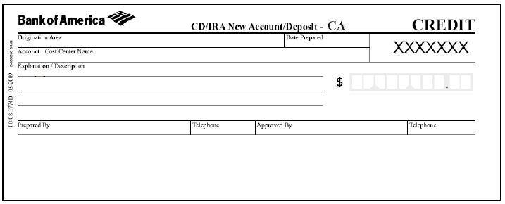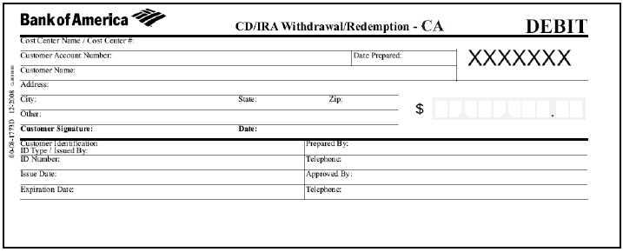

1. Closing Accounts
   1. Learning Objective: Upon completion of this topic, you will understand the new process in how accounts get closed.
   2. Accounts are closed by the seller on Interact before the closing transaction is processed at the teller line.
   3. Sellers can process the entries on Interact if the customer is transferring the closing balance to/from another account.
   4. Scenario: Pauline Montes comes into the banking center to close her account.
2. [Institutional Deposit Services (IDS) Accounts](http://pro.bankofamerica.com/portal/site/kmt09040064/menuitem.63a5bd088b6e4ad748be791021e3abba/?vgnextoid=44f50eabdc3a2210VgnVCM100000333ebaabRCRD&m=9cd4ee1a64a14210VgnVCM1000000d3ebaabRCRD)
   1. Learning Objective: Upon completion of this topic, you will understand that Commercial Bank accounts will not be available on Interact
      1. IDS accounts are viewable through COIN.
      2. Interact does not display any information for IDS accounts
      3. Deposits to Institutional Customer accounts are considered interstate transactions because current teller systems provide limited account information.
      4. The accounts have unique routing and transit numbers and proof codes.
      5. These accounts are identified with the Line of Business indicator 072W - Institutional Customer.
      6. When processing deposits to an Institutional Customer account, scan the pre-printed deposit ticket so that the correct entity will prefill.
         1. Commercial/business customers should be providing a preprinted deposit ticket. Counter documents should only be used on an exception basis.
      7. If the deposit ticket cannot be scanned, one of the following entities could apply:
         1. NGA - Georgia Controlled Disbursement
         2. NTX - Institutional Customer East
         3. NCA - Institutional Customer West
         4. NIL - Institutional Customer Illinois
         5. NMI - Intuitional Customer Michigan

**Procedure**

* Complete the following steps to process an Institutional Customer deposit.

|  |  |
| --- | --- |
| **Step** | **Action** |
| 1 | * Request a preprinted deposit ticket from the customer. * If the customer does not have a preprinted, pre-encoded deposit ticket, complete an Out of State Counter Deposit (95-14-4010B), as follows:   + Complete the deposit ticket legibly, including the account number and store number at the bottom of the form.   + Circle the Customer Connection box at the top of the deposit ticket; then write 90 in the two-digit proof code boxes at the bottom of the deposit ticket. |
| 2 | * Process the transaction on the system as a Commercial Deposit. * Enter the appropriate Institutional Customer code in the Entity field.   + The Entity Field, account number and store number (if applicable) will pre-fill when a preprinted deposit ticket is scanned. * For cash transactions **exceeding $10,000**, complete a Currency Transaction Report. |
| 3 | Place the transaction in your proof work. |

1. Funds Availability (Reg C)
   1. Explain the change to the funds available to the customer after a deposit
      1. CA customers will receive $200 next business day availability.
         1. If no hold, get entire deposit next business day.
         2. If hold, get $200 next business day.
      2. Funds availability at ATM will increase to $300 for customers of >1 year tenure.Currently, these customers receive $200, it’s based upon tenure, so those customers less than 31 days will receive the $200 credit on the next business day.
      3. Explanation on the change and how to handle customer questions
         1. Discussion on workarounds at the teller:It’s important to note that when customers go to the ATM they will have quicker access to their funds since they will get immediate availability of $200-$300. In addition, they can make deposits at the ATM up to 8:00 PM local time and still have the deposit processed on the same day.
         2. If they go to the teller, the funds will not be available until the next morning. Also, if customers go to the teller, they deposit is processed based upon the time the banking center is open - 6:00 PM in most cases. However, both, the ATM and teller deposits are processed overnight and posted to the customer’s account by the next morning.
         3. Cash out and Cash in
      4. Scenario: Linda Jones comes into the bank to deposit cash. When you explain to her that she won’t have access to her funds until the next business day, she gets upset. At this point, how do you de-escalate Linda’s frustrations and migrate her to use the ATM for immediate availability?
      5. Answer/Response: explain to Linda that you can help her gain immediate access to her funds by making the deposit at the ATM. Let her know not only is it quicker, because there’s no line to wait in, but also, explain the your deposit/your choice policy and they she gets immediate credit for her cash she deposited.
2. Cashier’s Check Changes
   1. Explain the stop payment process for official items.
      1. CA cashiers checks include the customer service phone number on the back of the check. CA customers can use the phone number to place a stop payment on the check. The customer service number will be removed post SD1 and Model procedures will be used to place stop payments on official items.
3. Safe Deposit Box Payments
4. Process safe deposit box payments electronically when possible (At what points, when is it not possible?)
5. Tellers may process safe deposit payments electronically.
6. Change on MerlinTeller.
7. Enter full ATM/Debit Card Number in MerlinTeller
   * 1. If an ATM/debit card cannot be read after swiping it in the Quick Service Terminal (QST), tellers can manually key in the card number to access the Customer Profile screen.
        1. In CA, tellers only key the last nine digits of the card number.
        2. In Model, tellers must key in all 16 digits of the card number.
8. Buy Sells for Cash
   1. Model MerlinTeller – complete form, processes the sell, then complete the buy.
9. New Account Kits
   1. Explain the new process for creating account numbers when opening new accounts.
   2. Determine how to prepare for New Account Kit shipments by identifying when to begin using the new pre-printed material.
      1. In the CA Legacy system when a new checking or new savings account is opened the system automatically generates the account number. For Interact the associate will need to type in the account number from the temporary checks/savings starter kits for all new checking and savings accounts, including Money Market accounts. (Interact only pre-populates CD and IRA new account numbers.)
      2. New Account Kits shipped and received in banking centers. Associates need to know when the new account kits will be shipped, when to expect delivery in the banking center and what to do with the kits prior to SD1.
      3. New account kits ordered after conversion will begin with the prefix 164.
10. Business Signature Cards
    1. Correctly fax business signature cards to Records Management
       1. When faxing business signature cards to Records Management, you must reset your fax machine to Duplicate so the front and back of the signature card are faxed.
       2. If fax is not set to Duplicate, the actual signers signatures will not be recorded.
11. Returns & Exceptions
    1. Use Vector 5 to successfully process an exception return.
    2. Identify Vector 5 cutoff time.
       1. Currently CA banking center associates pay rejected items directly from COIN. After SD1 associates will use Vector 5 exception processing.
       2. Cutoff time will move from Noon to the Model standard of 10 am local time.
12. Opening Attorney Client Trust Accounts
    1. Changing name to Interest On Lawyer's Trust Account (IOLTA) account
    2. Continue to use State Bar of California's TIN (94-6001385)
    3. CA: Contact Attorney Trust Accounting to open the account.
    4. Model: Open a business account on Interact.
       1. Create a new profile if the Legal Designation of the existing profile for the Attorney/Law Firm is other than IOLTA/IOTA.
       2. Select **Public Service Trust Account** as the Product
       3. Title:
          1. Line 1: Must contain the name of the state followed by the description "IOLTA Trust Accounts" (or other state specific description) to identify the purpose of the account.
          2. Line 2: Must contain the name of the appropriate business entity designation.